Contents
1. Where are Fusion Electronics Libraries stored? 2
2. What is a Fusion Electronics Library? 5
3. What is stored in a Fusion Electronics Library? 5
4. How is a schematic symbol and footprint linked? 7

Where are Fusion Electronics Libraries stored?
We must start by talking about the different types of libraries. There is a lot to unpack here. I’ll try to be as clear as possible.

Types of Libraries:
- Local Libraries
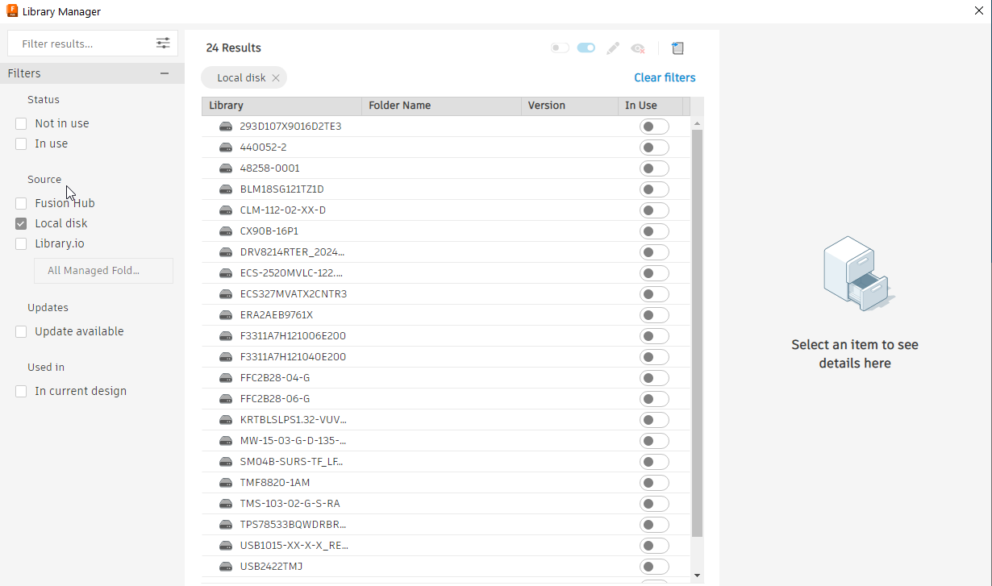
- Fusion Hub Libraries
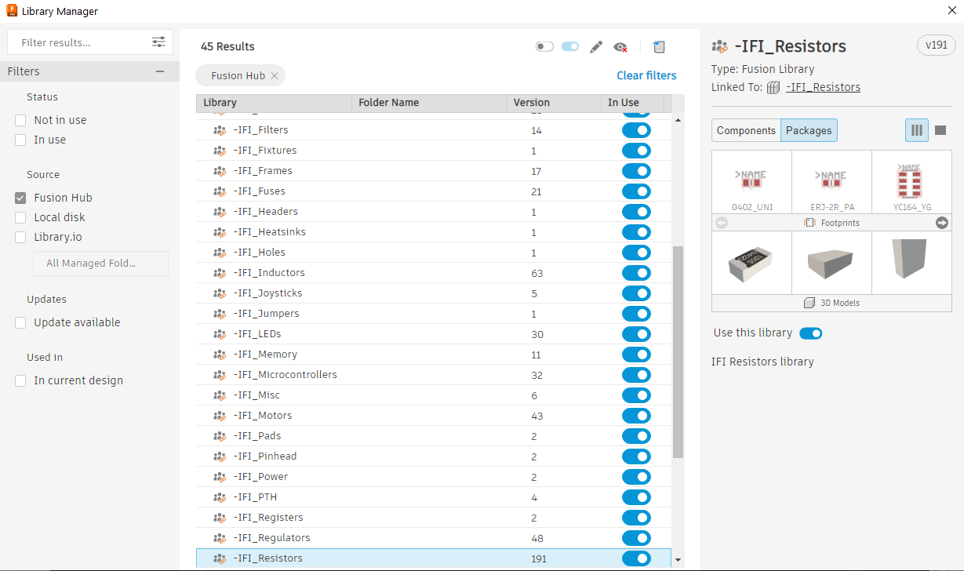
- Library.io Libraries
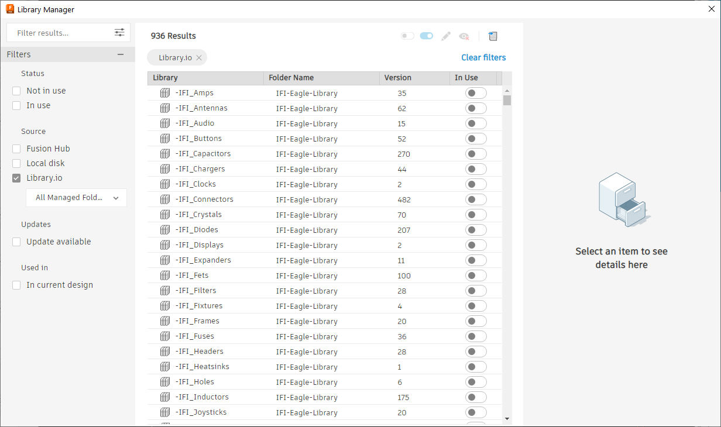

All these libraries can be accessed through the library manager if Directory paths are set up correctly in the Preferences.
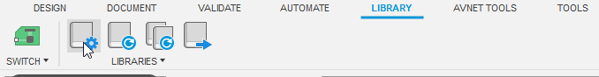 | 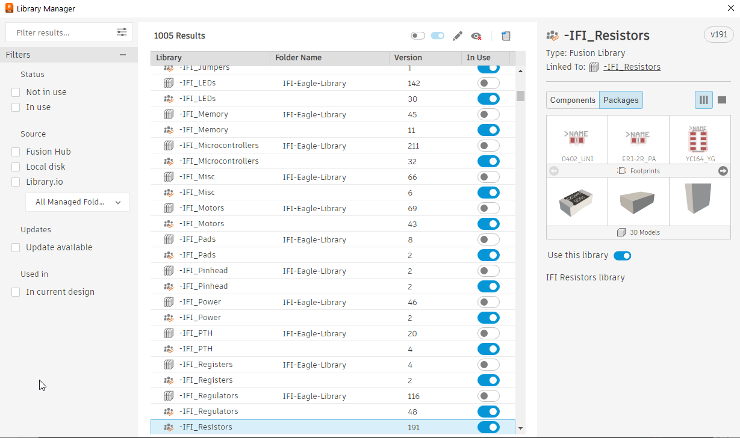
Accessing Library Manager | Unfiltered Library Manager Dialog
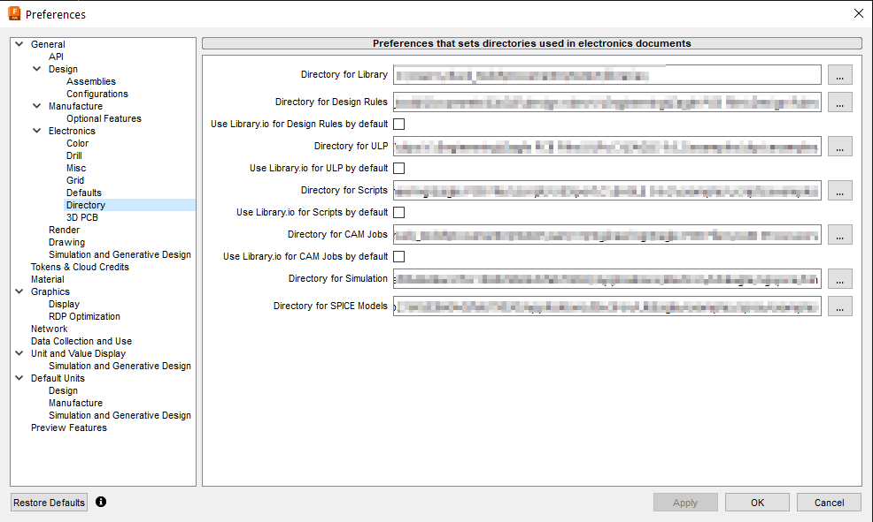
Directory Preferences

Local Libraries:
These libraries are stored on your local hard drive. They could contain a single component or multiple. They will most likely be downloaded from a manufacturer’s website and have a “.lbr” extension. These libraries can be imported into your Fusion Hub libraries.

Where I keep my local libraries is shown below.
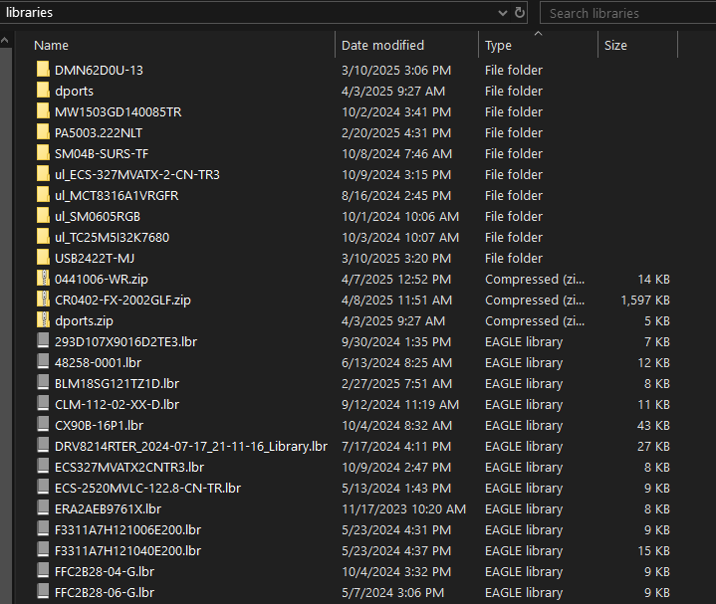

Fusion Hub Libraries:
These libraries are found in the Fusion Environment and are stored in the cloud. I created a Project (you could think of it as a folder) just for Fusion Libraries. Access to these libraries is through Data Panel .
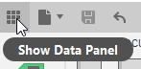

You can see that I am a member of the IFI_Fusion_Team Hub located in the upper left corner of the image below. This is a drop down that would show all the Hubs available to you.
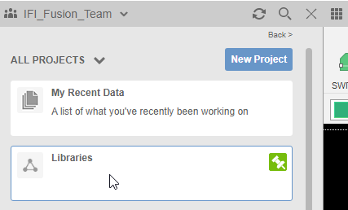
Double click to enter the Libraries project.
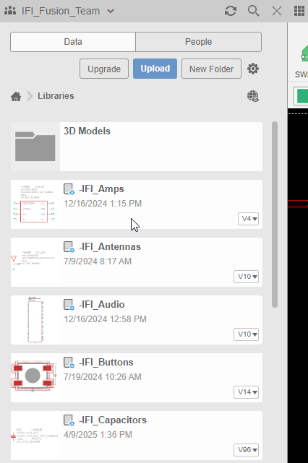 | 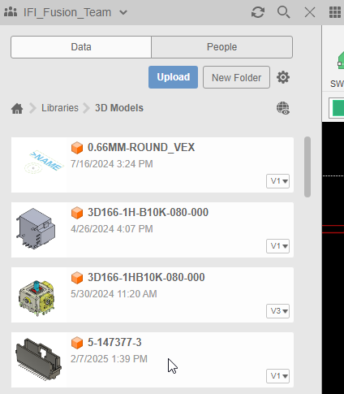
Libraries Project | 3D Models Folder
Local libraries can be imported directly into the Libraries project.
(Instead, I would open the Fusion Hub library that the local library would most likely relate to and import it there.)

As you can see, I have a folder for 3D Models in the Libraries project.

It is recommended that you use Fusion Hub libraries once the Library.io libraries have been imported.

Fusion Hub and Library.io libraries are linked after importing the Library.io libraries. Changes made in the Fusion Hub libraries can be pushed and pulled from the cloud.

Library.io Libraries:
These are legacy Eagle libraries and are stored in the cloud. They can be imported and turned into Fusion Electronics Libraries. Once they are imported into Fusion they become Fusion Electronics libraries.

After a Library.io library is imported into Fusion the two libraries are linked to each other.
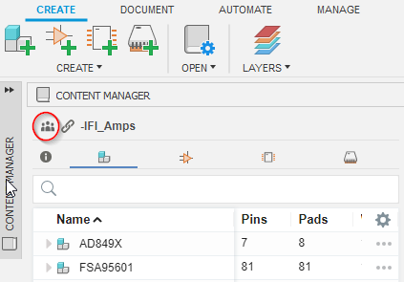 | 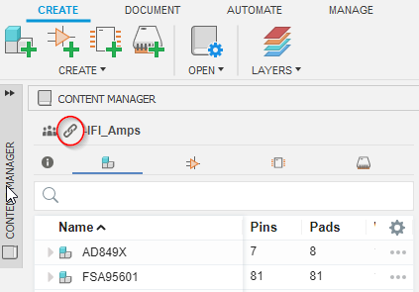
Fusion Hub Icon | Linked Icon
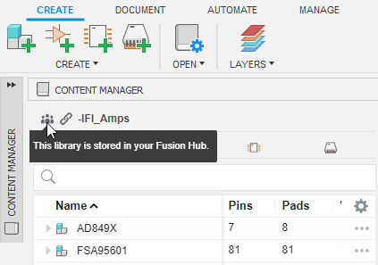 | 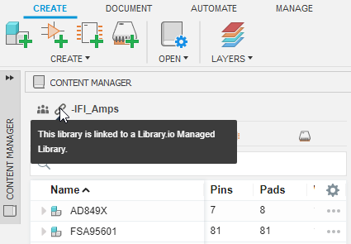
Stored in Fusion Hub | Linked to Library.io library

If someone were to modify a library.io library and push to the cloud the changes. The changes would be available to pull down to the Fusion Hub library and vise versa.

What is a Fusion Electronics Library?

A Fusion electronics library is a container for components that are stored in the cloud and is only relevant to the Fusion Hub you are a member.

What is stored in a Fusion Electronics Library?
Components are stored in a Fusion Electronics library.

Each component has 3 pieces.
- Schematic Symbol
- Footprint
- Package (3D Model)
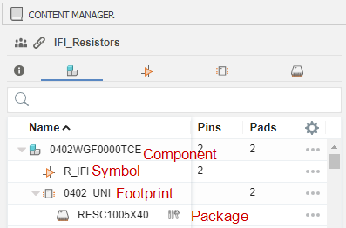

Components:
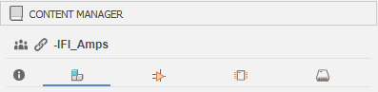
Components can be found in the content manager and links the Schematic Symbol and Footprint together.

Schematic Symbols:

Schematic Symbol can be found in the content manager and is a representation of the component with all the pins.

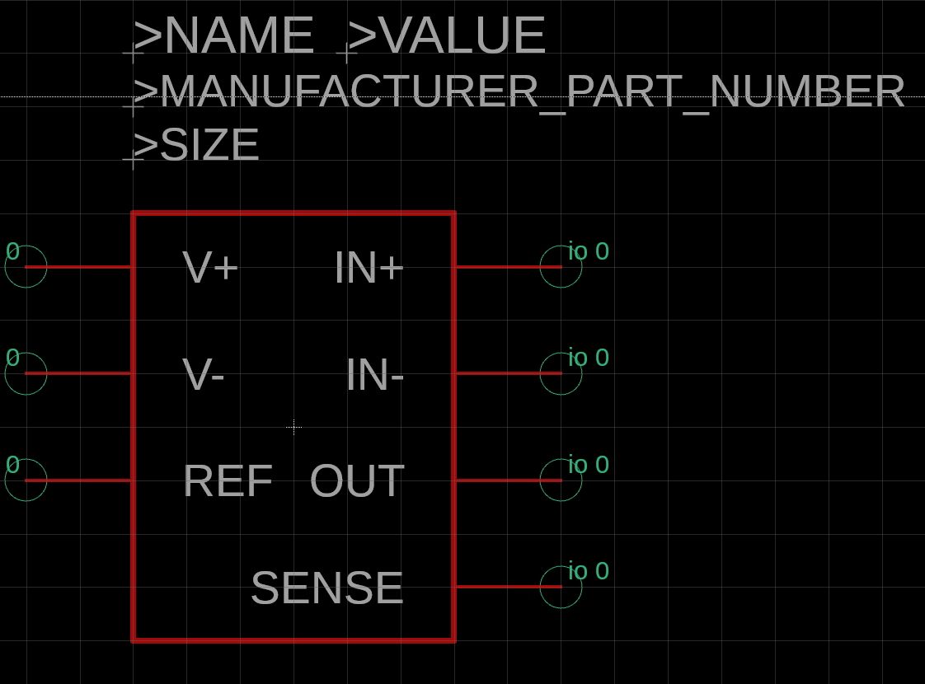
Figure 2: Schematic Symbol

Footprints:
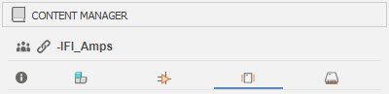
Footprints can be found in the content manager and is made up of pads, outline, etc.

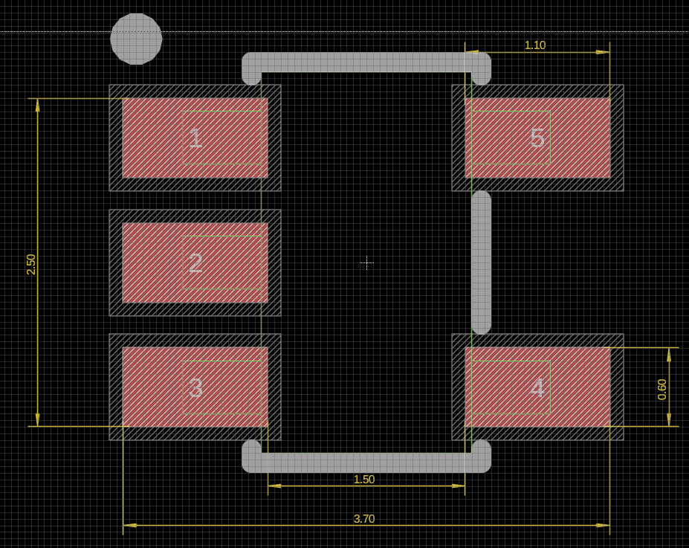
Figure 3: PCB Footprint
Packages:
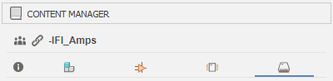
Packages can be found in the content manager and is a 3D representation of the component.

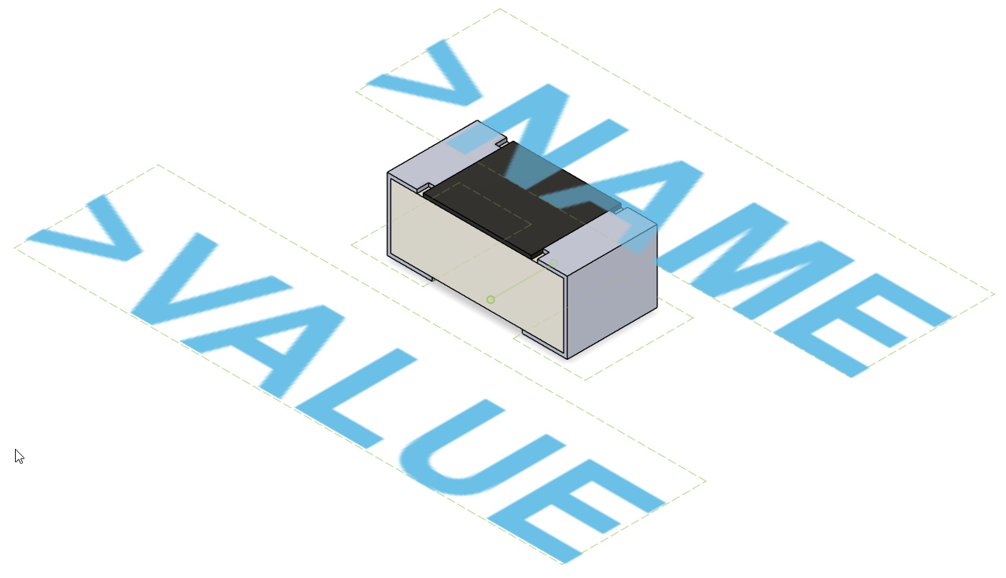
Figure 4: 3D Package

How is a schematic symbol and footprint linked?
Asssumptions:
- Schematic symbol is already created.
- PCB footprint is already created.

Create new component . Give the component a name.
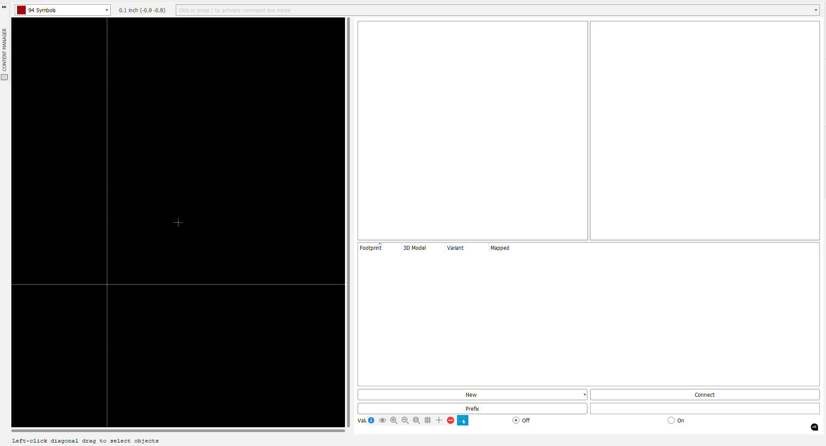
Figure 5: Blank Component
Add a schematic symbol to the component .

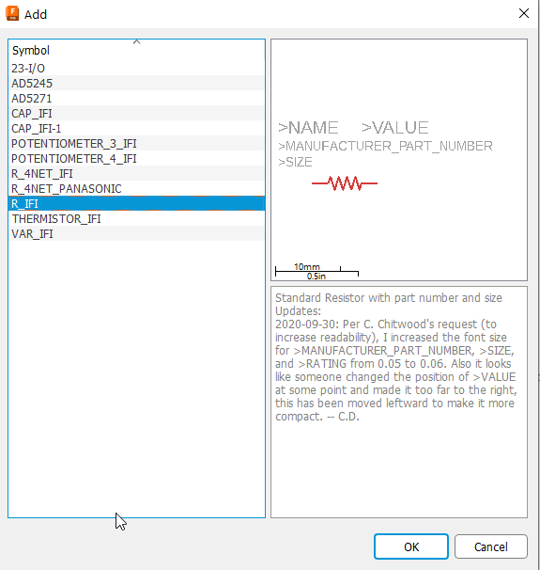
Select a symbol and click ok.

Place the schematic symbol on the origin as shown below.
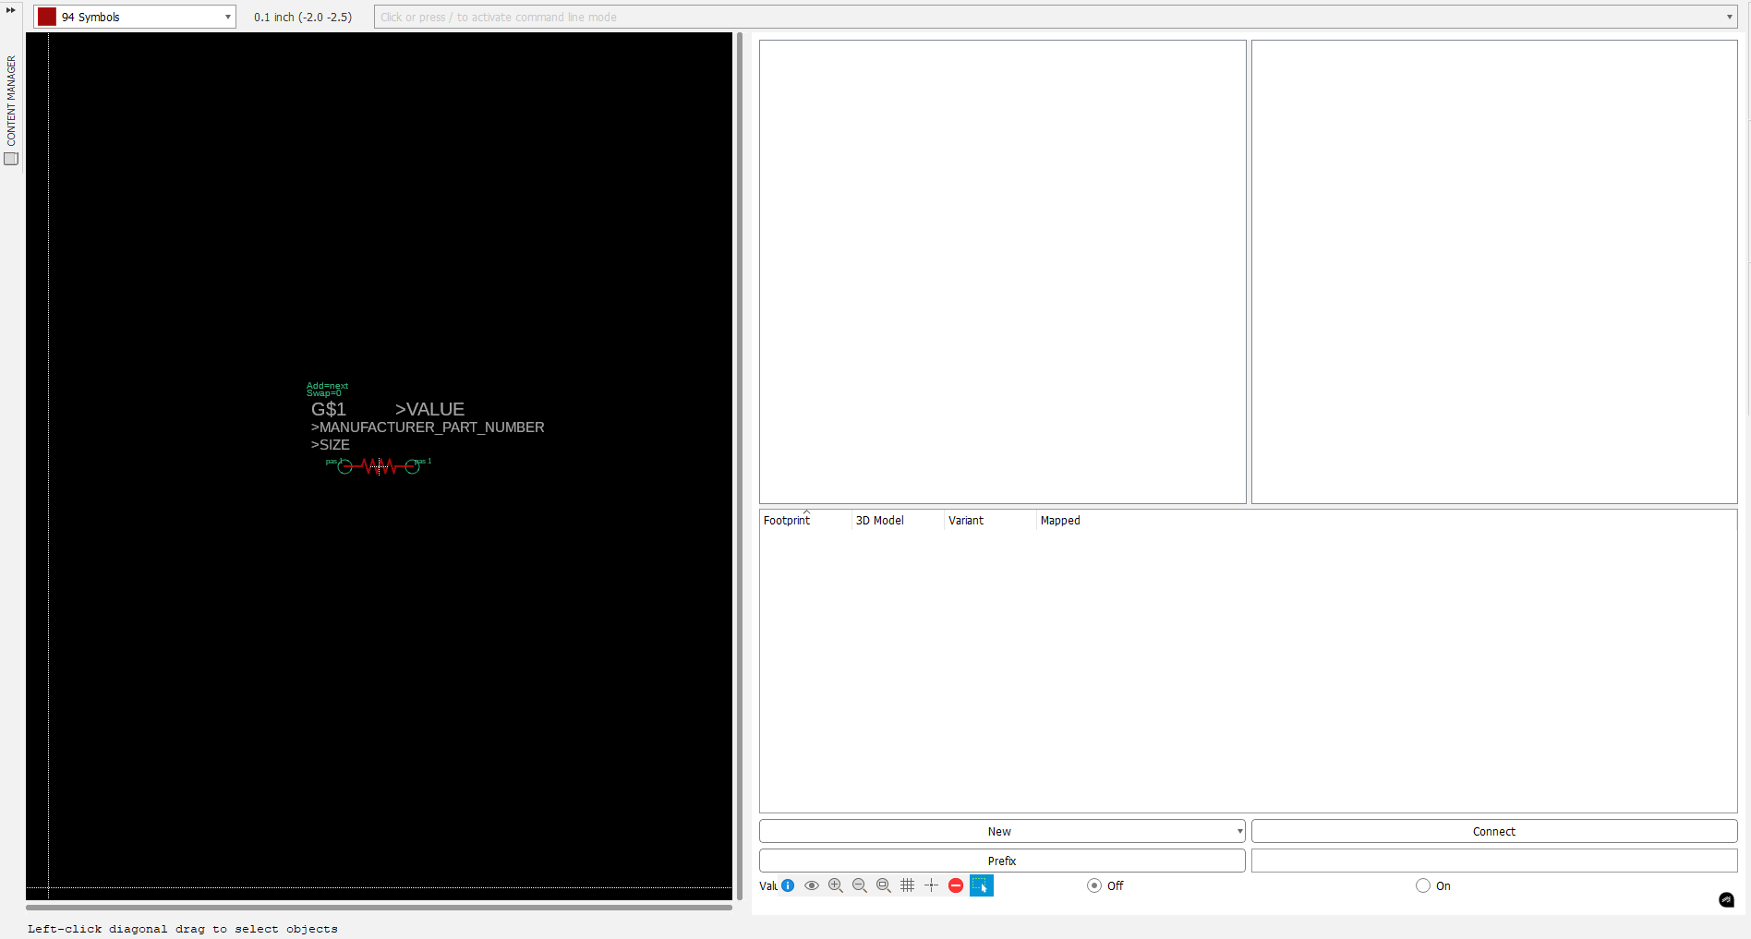

Add a footprint to the component.
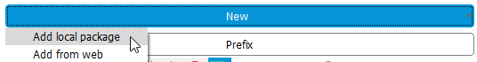

Select the appropriate footprint. Click OK.
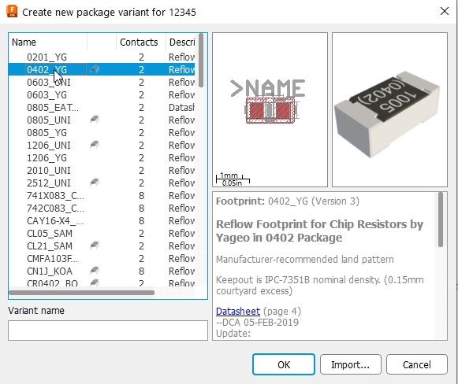

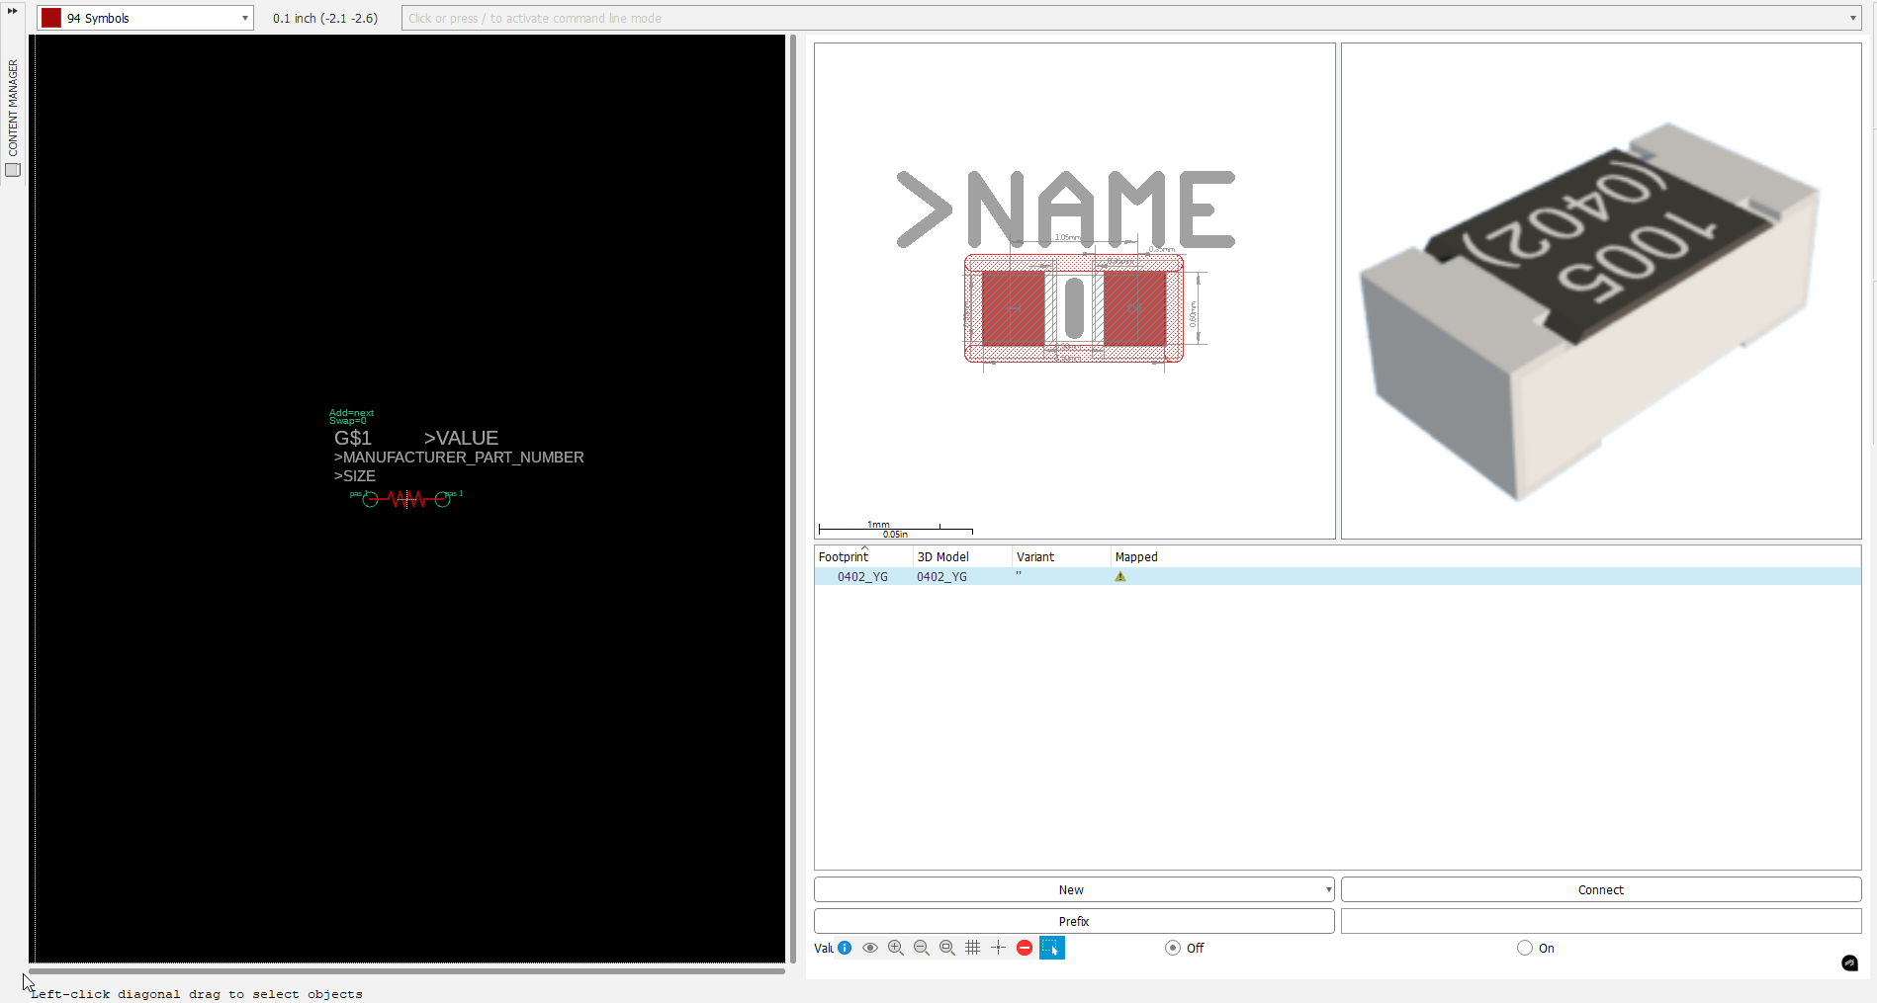
Connect the schematic symbol to the footprint.

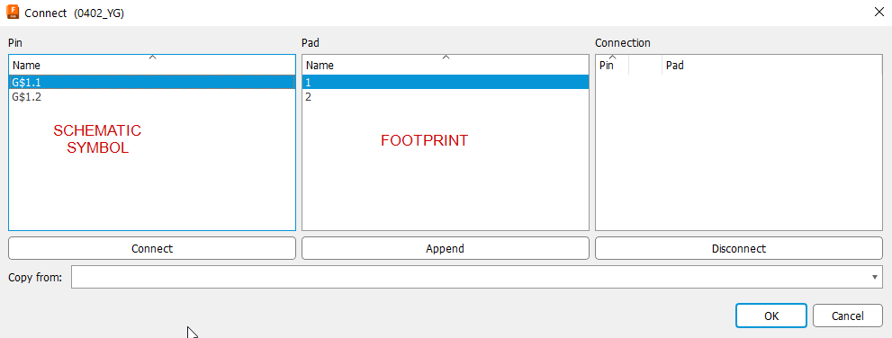

Connect schematic symbol pin 1 (G$1.1) to footprint pin 1.
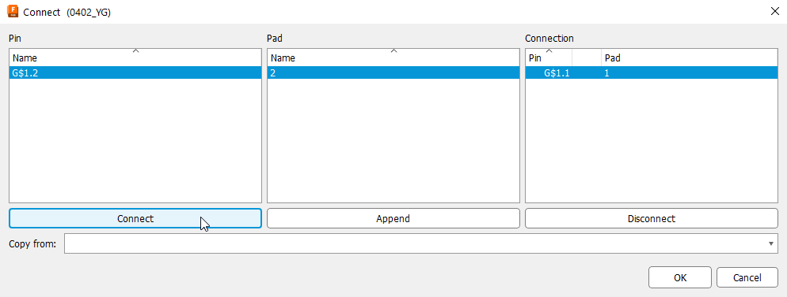

Connect schematic symbol pin 2 (G$1.2) to footprint pin 2.
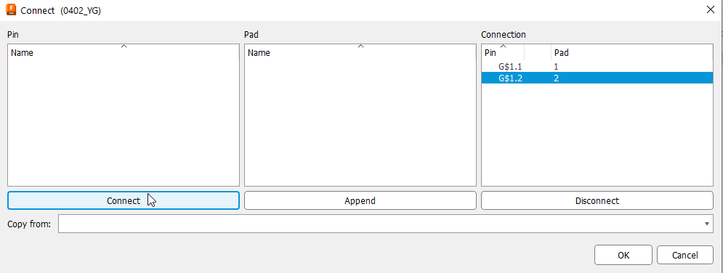
Click OK. Component is ready to use.

